Developed: Nitesh Yetta

Version : v1.0

JSON Read & Write in file

Description : Requirement proposed was to read the JSON and Write in the file.

Files Provided: 

Project Directory Structure:

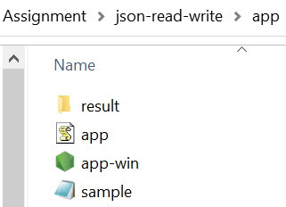

Expectation is to generate file in result and data should be visible in tabular format.

**RUN Steps**:

Step 1 : Extract the file in local drive, I have share on drive



Step 2 open command prompt. In windows go to Run> cmd (type this command in text box)

Step 3 Run the command as below

Go to app folder > run > app-win.exe sample.json jsontoTable.html

Please see below screen short.



Result:

